PROJECT REPORT
On
“SmartShop online smartphone selling site”

Submitted for partial fulfillment of requirement for the award of degree
Of
Bachelor of Science (computer science)
In
University of Kabianga

March 2018

Supervised by:-
Dr. Patrick Bii

Submitted by:-
MOGAKA ESTHER NYARANGI COM/023/15
PETER WANJOHI COM/012/15
GICHANA A JACKLINE COM/011/15
MWANDOE TAI KELVIN COM/024/15

Department of mathematics and COMPUTER

university of kabianga
p. o. box 2030 – 20200 kericho
ii

DECLARATION
We, the undersigned, declare that this is our original work and has not been submitted to any University, College or any Institution of higher learning other than University of Kabianga

NAME SIGN
Mogaka Esther Nyarangi Sign…………………………….
Gichana A Jackline Sign…………………………….
Mwandoe Tai Kelvin Sign…………………………….
Peter Wanjohi Sign…………………………….
DATE…………………

This project report is hereby presented for examination with the approval of the project supervisor.
LECTURER: DR. PATRICK BII
SIGN…………………..
DATE.............................

iii
DEDICATION
The proposal is dedicated with much appreciation to God for giving us strength, our families and friends for giving us much support. We also thank and appreciate our supervisor who taught us that even the largest task can be accomplished if done one step at a time, also classmates and the university of Kabianga fraternity at large for making this proposal success.

iv

ABSTRACT
Mobile and e-commerce applications are tools for accessing the Internet and for buying products and services. These applications are constantly evolving due to the high rate of technological advances being made. The Kenyan smartphone market continue to experience substantial growth and its easy to see why. The combination of a strong economic climate and increasing internet and mobile connectivity has created a favorable competitive landscape which has brought more brands and cheaper devices to the market. This website involves marketing of smartphones. Customers can view the site, view products ,select their choice and make orders. Customers can also proceed to checkout to make their payment through an online payment gateway(jambo pay gateway).After payments are verified, the products are then shipped to the customer location.

v

ACKNOWLEGEMENT:
We sincerely give thanks to the Almighty God for giving us strength throughout the preparation of this project. We also express our gratitude to our families for their support, our classmates, friends and the clinic staff of the University of Kabianga who made various contributions to the successful completion of this project.
We would like to express deepest gratitude to our supervisor Dr. Patrick Bii for his extra ordinary efforts in providing guidance and motivation in making this project a success.
Finally, we acknowledge our heartiest thanks to the individuals who contributed towards the development of this project. Your comments, criticism, corrections and suggestions for improving this report are appreciated.

TABLE OF CONTENTS
DECLARATION II
DEDICATION III
ABSTRACT IV
ACKNOWLEGEMENT V
CHAPTER ONE 1
INTRODUCTION 1
1.0 Introduction 1
1.2 Statement of the problem 1
1.3 Purpose 2
1.4 Objectives 2
1.5 Significance 2
1.7 Limitations 3
1.8 Theoretical framework 4
1.9 Definition of terms 4
CHAPTER TWO 5
LITERATURE REVIEW 5
2.0 Introduction 5
2.1 Background 5
2.2 Existing Systems 5
2.3 Contributions 6
CHAPTER THREE 7
SYSTEM DESIGN 7
3.0 Introduction 7
3.1 Research methodolgy 7
3.1.1Questionnaires 7
3.2 Development methodology 8
3.3 Feasibility Study 11
3.4 13
3.5 Interaction (Sequence/Collaboration) Diagram 13
3.6 Functional Requirements 14
3.7 Non – functional reqiurements 14
3.8Implementation requirements 15
CHAPTER FOUR 16
SYSTEM IMPLEMENTATION 16
4.0 Introduction 16
4.1 Implementation Methodology 16
4.2 Testing 17
CHAPTER FIVE 20
DISCUSSION, CONLUSIONS AND RECOMENDATIONS 20
5.0 Introduction 20
5.1 Discussion 20
5.2 Conclusion 20
5.3 Recommendations 20
5.4 Future work 21
REFERENCES 22
APPENDICES 23
Appendix A Gant Chart Time schedule 23
Appendix B Budget 24
Appendix C Instruments 25
Appendix D User Guide 27
Appendix E Sample code 30
Appendix F Sample Input 32
Appendix F Sample Output 32

CHAPTER ONE

INTRODUCTION

1.0 Introduction
Due to the growing demand to buy smartphones we developed this website to make online shopping easier whenever, wherever and also search and find what customers like. The website is used customers to acquaint themselves with the various types of phones and available. Also, the website reduced the need for the manual shopping whereby the customer has to move from one shop to another to compare prices and then purchase the product thus saving time and unnecessary costs.
1.1 Background
This website “Smart shop” enables customer to buy smartphones and tablets from anywhere through online. This application advertises some of the products for shopping. To buy products, customer has to create an account. Those who do not have an account can only view the available product. They cannot buy it. Once the customer has created account, not only he can view the products, he can also add the product to the cart and also he can place an order to buy those products. This application then generates bill for that particular customer. After the confirmation, the customer has to enter his credit card details to buy those products.
The website will be developed completely independent and dynamic . Customer must have an account to purchase the product. This application stores all the information in the database which can be retrieved whenever needed and all the validations are performed during the entry of the data by the user thus ensuring that the customers cannot enter any wrong data which could cause problems later. The confirmation of debit card numbers will be handled by the jambo pay.
It is designed such a way that one can view all the updates of the mobile from any place through online. The software will help in easy maintaining and updating products in the website for the administrator. Also quick and easy comparison of different products for the customers.

1.2 Statement of the problem
Customers spend a lot of time moving from one shop to another looking for specific varieties, comparing prices and checking for the latest versions of their favorite phones. This leads to incurrence of unnecessary costs. This website will help in solving this problems whereby customers can view and purchase products from anywhere at any time. Users can also compare prices and get updates for latest smartphones automatically from the site.

1.3 Purpose
This website is aimed at developing a Web application that depicts online Shopping of smartphones and purchasing using Jambo Payment Gateway. Using this website, companies can improve the efficiency of their services. Online Shopping is one of the applications to improve the marketing of the company’s products. This web application involves all the features of the online shopping.

1.4 Objectives
- This software helps customer to find different mobiles, their features, and new updates easily. It is designed in such a way that one can view all the updates of the mobile from any place online.
- The software will help in easy maintaining and updating products in the website for the administrator.
- Also quick and easy comparison of different products for the customers.
- To increase convenience- don’t need to stress yourself going to a shop, you can shop from anywhere you wish conveniently and smartly.
- To improve security- you only shop from trusted online website.
- To guarantee Original high-quality product -Buying online prevent you from being cheated by middlemen that will convince you to buy fake low quality product.

1.5 Significance
- Convenient and stress free: The good thing about shopping online in Kenya is that you know you can shop at anytime, any day and all the time. Also, you don’t have to make a physical appearance at the store. Added to that, know that you can shop from anywhere, the car, home, office and even when taking a dump.
- Best prices, offers, deals- some of the best deals can be found online.It is rear that you find a price that beats or matches that of an online store in a brick and mortar store. Sometimes, it is because there is no middleman. The online store might be dealing with the manufacturer directly.
- Variety of Products-Almost all types of smartphones can be found in our website .The convenience of spending little energy to browse the online store is “neat”. On the other hand, to cover all even half of a shop that sells phones these days takes a lot of energy.
- Minimized expenses- the price moving from one shop to another is higher if you compare with the delivery charges of online stores. .
- Easy Price Comparison-You can easily compare the price of various available goods online. This will enable you to make the best choice when it comes to price. The days of walking around with a pen a pieces of paper noting down the various prices of goods are long gone.
- You can make discreet purchase- You will enjoy the luxury of being able to buy whatever you need.
- Delivery in all parts of Kenya-The best thing about buying online is that you will have the goods delivered to you at the most convenient location. Our website will deliver to all major towns in Kenya.
1.6 Scope
Scope of the project:
This system will reduce the manual operation required whereby the customer has to move from one shop to another. Main concept of the project is to capture the customer details ,record transactions and generate receipts for a respective customer as well as the delivery of the product. Hence this software can be used by any smartphone selling companies to maintain their record easily and improve their online services.
The system maintains two levels of users:-
- Administrator Level.
- User Level.

1.7 Limitations
- Shipment fee-there is a charge on shipping the product to the customer hence this may make a customer prefer to look for alternatives.
- Delay in Delivery-the time taken for a product to reach a customer varies from place to place .
- It is limited to computer literate customers-. A person who has no knowledge of computers will find it difficult to understand the website.
- Security issues -This system is provided with authentication, without this user cannot purchase the products. So only the legitimate users are allowed to use the application. If the legitimate users share the authentication information then the system is open to outsiders.
- Since it is an online project, customers need internet connection to buy products.
- Fraud-existence of hackers.
- Deprives our tangibility.

1.8 Theoretical framework
Our project idea was borrowed from Jumia Market which was founded by Jeremy Hodara and Sacha Poignonnec in February, 2013. The company started operations in Nigeria and Pakistan that same year under the name Kaymu; after receiving an undisclosed amount of seed funding from Rocket Internet . The company grew from an employee base of ten to sixty within first nine months and opened operations in Ghana and Morocco in October, 2013. By June 2015, Kaymu had expanded its operations to Algeria, Saudi Arabia, Croatia and Angola Mozambique, Bangladesh, Nepal, Myanmar, Slovenia, Sri Lanka, Bulgaria, Uzbekistan, and the Philippines, bringing the total number of countries to 35.
Jumia Market employs eBay's business model, serving as an online mall where sellers and buyers meet to make transactions. The company launched its smartphone apps for Android, iOS and Blackberry in September, 2014 tapping into the tremendous growth of mobile technology, especially on the African continent. In March 2016, AIG announced that top tier investment bank, Goldman Sachs and French Insurance company AXA, had joined its list of investors with both investing a cumulative sum of over $300 million. In June 2016, AIG, via a combination of a live Periscope broadcast and Twitter feed updates, announced that it was merging all its online brands into one company: Jumia. As a result, platforms exploring food, real estate, automobile, travel, and general goods market, became a part of the Jumia franchise.

1.9 Definition of terms
CSS – Cascading Style Sheet
HTML- Hypertext Markup Language
PHP – Preprocessor Hypertext
XAMPP – Cross-platform Apache, MariaDB, PHP, Perl.

CHAPTER TWO

LITERATURE REVIEW

2.0 Introduction
The retail industry has been advocating “Smart Shopping” for many years by adopting various technologies to enhance the shopping experience at the retail environment. The vision of smart shopping promises is to provide on-the-spot information about various discounts, schemes, etc. at your fingertip.
Our website will provide the following factors to the customers for better usability :
- Knowing when an item was saved or not saved in the shopping cart.
- Returning to different parts of the site after adding an item to the shopping cart.
- Easy scanning and selecting items in a list.
- Effective categorical organization of products.
- Simple navigation from home page to information and order links for specific products.
- Obvious shopping links or buttons.
- Minimal and effective security notifications or messages.
- Consistent layout of product information.

2.1 Background
Given that we have a know-how in information technology, we decided to exploit it and do this project so as to improve the efficiency in service and delivery to the customers .This software helps customer to find different mobiles, their features, and new updates easily.- It is designed such a way that one can view all the updates of the mobile from any place through online.It will help in easy maintaining and updating products in the website for the administrator. Also quick and easy comparison of different products for the customers. It will increase convenience-don’t need to stress yourself going to a shop , you can shop from anywhere you wish conveniently and smartly .It will improve security- you only shop from trusted online website . Finally it will guarantee Original high-quality product -Buying online prevent you from being cheated by middlemen that will convince you to buy fake low quality product .

2.2 Existing Systems
The current system is a manual system where the customers have to go to a shop to look for the specified product. This is usually time consuming and also leads to incurrence of unnecessary costs.
The challenges faced by the current system include:
- Long queues in the phone shops.
- Huge waiting time.
- Carrying heavy items home.
- Not convenient one must go to the shop.
- No updates unless you visit the shop
- No discreteness.
- Incurrence of unnecessary costs.

2.3 Contributions
The following are the major contributions that have been made by the current system
- Increased convenience and being up to date.
- Minimized expenses
- Variety of products.
- Easy Price Comparison-
- You can make discreet purchase
- Delivery in all parts of Kenya

CHAPTER THREE

SYSTEM DESIGN

3.0 Introduction
The design description contains the design and architecture of the system that includes data structures, software architecture, interface representations, algorithmic characteristics.
All entities and components are described in the SDD using formal documentation along with UML diagrams, such as:
• Class Diagrams
• Collaboration Diagrams
• Sequence Diagrams
• ER Diagrams

3.1 Research methodolgy
The researcher was able to collect the relevant data with the help of the following data collection methods and techniques.
These data collection methods are as indicated below:

3.1.1Questionnaires
Quality responses were able to be gained from the potential customers with the use of both, open –ended and closed questionnaires without fear of being victimized
Open ended questionnaires were used to give a chance for the respondent to give an opinion and to give useful insight to the problem.
Advantages
- It provided a cheap way of collecting data because it just required designing a sample of questions and sending them to the clinic personnel and waiting for the responses after duration of time.
- The responders had enough time to refer to necessary documents.
- It was possible to collect information from a large number of the respondents within a short time.
- The respondents were not much interrupted from the working places.
- The data collected was likely to be real because anonymity was maintained.

Disadvantages
- There were cases of misunderstanding of questions and therefore it required a follow-up.
- Some of the responders were ignorant and therefore they never took serious the questions and therefore could not get full data.
- Closed questions were the most suited to carry out the method in to which the responders where allowed to choose only a single choice.
- A lot of time was used to design the questionnaire.
- Most of the questionnaires were not completely answered.
- Some of respondents did not return the questionnaires.

3.2 Development methodology
Developmental methodology of the system falls under Waterfall model, in which each module was designed until the testing stage.
The following activities were carried out by the group during our project design and implementation period.
Requirement Specification

Analysis

Software design

Testing of the software

Software implementation

- Requirement Specification-this involved establishment of requirements for all the system elements and then allocating the subset of this requirements to the software.it was essential for interfacing correctly with the external elements including the database and other hardware.
- Analysis – in this phase the requirements gathered were focused on the software. They were reviewed regularly. Analysis of fact finding also occurred at this stage.
- System design -The team of experts came up with just but a sketch of the software focusing on the four distinctive attributes of the software. Features of the new system will be specified and benefits to be derived estimated .The programming language and also platform in which the new system will run is also decided .The I/O processing specifications are also drawn up in detail.
- Testing – this involved a test run on the system to remove any bugs if any. The output of the test run should match the expected output. The tests to be carried out include:
- Implementation and Unit Testing –this involves testing individual modules. Any undesirable output is noted and debugged.
- Integration and System Testing- This involved testing the software as a whole by integration.
- System production and Maintenance- in this stage the system will be presented to the end user and a group of expert will validate if the system meets the user’s specifications gathered.
Data Flow Diagram
Level 0
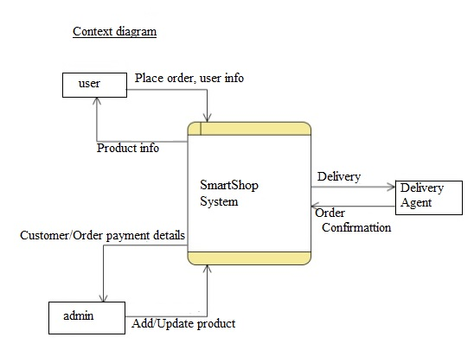

Level 1
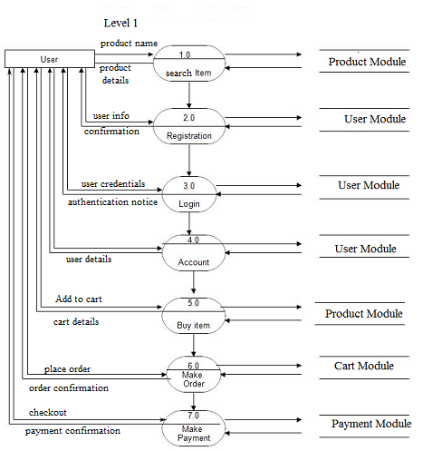
Stages of design
- Problem understanding
It involves looking at the problem from different angles to discover the
design requirements.
- Identify one or more solutions
  - Evaluate possible solutions and choose the most
appropriate depending on the designer's experience and
available resources.

- Describe solution abstractions
  - Use graphical, formal or other descriptive notations to
describe the components of the design.

3.3 Feasibility Study
Feasibility is defined as the practical extent to which a project can be performed successfully. To evaluate feasibility, a feasibility study is performed, which determines whether the solution considered to accomplish the requirements is practical and workable in the software. Information such as resource availability, cost estimation for software development, benefits of the software to the organization after it is developed and cost to be incurred on its maintenance are considered during the feasibility study. The objective of the feasibility study is to establish the reasons for developing the software that is acceptable to users, adaptable to change and conformable to established standards. Various other objectives of feasibility study are listed below.

- To analyze whether the software will meet organizational requirements
- To determine whether the software can be implemented using the current technology and within the specified budget and schedule
- To determine whether the software can be integrated with other existing software.
.

Eight steps involved in the feasibility analysis are:
- Form a project team and appoint a project leader.
- Prepare system flowcharts.
- Enumerate potential proposed system.
- Define and identify characteristics of proposed system.
- Determine and evaluate performance and cost effective of each proposed system.
- Weight system performance and cost data.
- Select the best-proposed system.
- Prepare and report final project directive to management.
There are three aspects to the question of feasibility:
Technical Feasibility:
Technical feasibility assesses the current resources (such as hardware and software) and technology, which are required to accomplish user requirements in the software within the allocated time and budget. For this, the software development team ascertains whether the current resources and technology can be upgraded or added in the software to accomplish specified user requirements. Technical feasibility also performs the following tasks.
- Analyzes the technical skills and capabilities of the software development team members.
- Determines whether the relevant technology is stable and established.
- Ascertains that the technology chosen for software development has a large number of users so that they can be consulted when problems arise or improvements are required.
Operational feasibility :
Assesses the extent to which the required software performs a series of steps to solve business problems and user requirements. This feasibility is dependent on human resources (software development team) and involves visualizing whether the software will operate after it is developed and be operative once it is installed. Operational feasibility also performs the following tasks.
- Determines whether the problems anticipated in user requirements are of high priority
- Determines whether the solution suggested by the software development team is acceptable
- Analyzes whether users will adapt to a new software
- Determines whether the organization is satisfied by the alternative solutions proposed by the software development team.

Economic feasibility
It determines whether the required software is capable of generating financial gains for an organization. It involves the cost incurred on the software development team, estimated cost of hardware and software, cost of performing feasibility study, and so on. For this, it is essential to consider expenses made on purchases (such as hardware purchase) and activities required to carry out software development. In addition, it is necessary to consider the benefits that can be achieved by developing the software. Software is said to be economically feasible if it focuses on the issues listed below.
- Cost incurred on software development to produce long-term gains for an organization
- Cost required to conduct full software investigation (such as requirements elicitation and requirements analysis)
- Cost of hardware, software, development team, and training.
The technical feasibility is frequently the most difficult area encountered at this stage. It is essential that the process of analysis and definition be conducted in parallel with an assessment to technical feasibility. It centers on the existing computer system (hardware, software etc.) and to what extent it can support the proposed system.

3.4 Use Cases
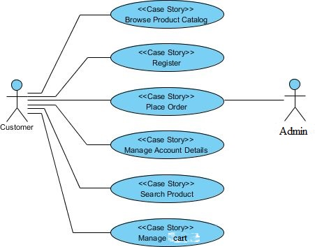

3.5 Interaction (Sequence/Collaboration) Diagram

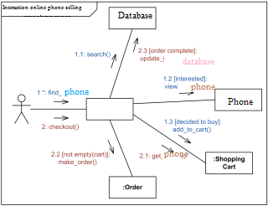

3.6 Functional Requirements
These describe what the software should do and also define the internal working of the software. The following are some of the functional requirements for the system at hand;

Login Module: Input: Admin or user enters the Login Id and password.
Process Definition: Checks whether login Id and password are valid or not. Output: Admin is directed to next page where he can add, delete or update the products. Users are directed to next page to view products.
New user Module: Input: Customer enters their details to create new account. Process Definition: Checks whether he entered all the details or not. Output: Customer is directed to the next page where he can view all the available products
Product Module: Input: Admin adds the new product which can be viewed by the users. Process Definition: Checks whether all the fields are entered properly or not. Output: Records will be added to the database.
Search Module: Input: This module helps the customer to ease his search based on his interest. The search can be done on different categories like mobile model name, model number, colour, price etc Process Definition: It retrieves the selected category from the database Output: Displays what the subscribers like to search.
Cart Module: Input: User can select any number of Mobile and add to the cart. He can also remove from the cart if he dislikes it later. Process Definition: Checks whether all the fields are entered properly or not. Output: Records will be added to the database.
Payment Module: Input: This module describes the payment done by the customer. The payment information can include information like the model purchased, quantity, mode of payment etc. Process Definition: Checks whether all the fields are entered or not. Output: Displays the payment done by the customer.

3.7 Non – functional reqiurements
These describe how the system works
Usability: the system should be easy to use by customers.
Maintainability: the system must be easy to modify and maintain.
Effectiveness: This means that system should perform well in relation to the effort.
Interoperability: the system should be able to work with any operating system easily.
Efficiency: the system must give good result within amount of time.
Security: the system should be secured from un-authorized access.
Accessibility: we must make sure that the system be accessible for all authorized users and not accessibility by anyone else.
Extensibility: the system must be customizable.

3.8Implementation requirements
The implementation requirements for the system are both hardware & software requirements

Hardware
- 2 GB RAM
- 1 GB and above flash disk
- 15 GB and above hard disk space
- Intel Pentium with 2 GHz or higher processor speed
- Local Network Area
Software
- Windows 8.1.
- Sublime Text Editor
- XAMPP server
- Languages used: Frontend JavaScript, HTML, CSS. Backend PHP

CHAPTER FOUR

SYSTEM IMPLEMENTATION

4.0 Introduction
Implementation is a critical phase, and as such, the installation process is customized to fit the needs of the website, while still following the concepts outlined here. This implementation is an evolutionary methodology that can be followed for successful system integration within the website.

4.1 Implementation Methodology
Installation
At this Phase, the admin can physically setup and install all hardware needs established in the implementation requirements above. In addition, a Systems Engineer(s) can test network connectivity and install the software and initialise database

- System Hardware and Network—Setup and installation of the hardware and networking components is a key step of this phase. Hardware may include the server(s), workstation(s), and label printer(s) and networking may refer to IP addresses and/or in-wall wiring.

- Development and Production Environments— if desired a development/test environment can be deployed in addition to the production environment, which will be the user’s active system.

- Software -The timeline for the software installation can be established any time and is dependent on having the hardware and networking components in place.

- Training —the website has its associated user manual which can be used to train users and also a formal training session of the users can be carried out.

Configuration
During this phase in the process, the developers will configure and install the other required necessity of the website. Meanwhile, the Systems Engineer(s) can perform system verification to confirm that the website is working as designed, configure instrument interfaces, and conduct onsite training .

- Interfacing—website interfaces are incorporated within the Configuration Phase.

- System Verification—Verification is a shared responsibility between the developers and the users. This is accomplished using a combination of manual and automated methods. Ensuring that the application has been set up properly and configured as required. Confirming the accuracy of individual data elements such as customer registration information .

- On-site Training— Developers can provide on-site training for key personnel. We can utilize a “Train the Trainer” approach when completing software implementations. This allows users to be trained thoroughly on the application.

4.2 Testing
Testing is a process of executing a program with the intent of finding errors.
A Successful test case is one that uncovers an as- yet-undiscovered error. System testing is a stage of implementation, which is aimed at ensuring that the system works accurately and efficiently as per the user need, before the live operation commences. As stated before, testing is vital to the success of a system. System testing makes a logical assumption that if all parts of the system are correct, the goal will be successfully achieved. A series of tests are performed before the system is ready for the user acceptance test.
TESTING METHODS
System testing is the stage of implementation. This is to check whether the system works accurately and efficiently before live operation commences. Testing is vital to the success of the system. The candidate system is subject to a variety of tests: on line response, volume, stress, recovery, security and usability tests. A series of tests are performed for the proposed system is ready for user acceptance testing.
The Testing Steps are:
- Unit Testing Unit testing focuses efforts on the smallest unit of software design. This is known as module testing. The modules are tested separately. The test is carried out during programming stage itself. In this step, each module is found to be working satisfactory as regards to the expected output from the module.
- Integration Testing Data can be lost across an interface. One module can have an adverse effect on another, sub functions, when combined, may not be linked in desired manner in major functions. Integration testing is a systematic approach for constructing the program structure, while at the same time conducting test to uncover errors associated within the interface. The objective is to take unit tested modules and builds program structure. All the modules are combined and tested as a whole.
- Validation At the culmination of the integration testing, Software is completely assembled as a package. Interfacing errors have been uncovered and corrected and a final series of software test begin in validation testing. Validation testing can be defined in many ways, but a simple definition is that the validation succeeds when the software functions in a manner that is expected by the customer. After
- Output Testing After performing the validation testing, the next step is output testing of the proposed system, since no system could be useful if it does not produce the required output in a specific format. The output format on the screen is found to be correct. The format was designed in the system design time according to the user needs.
- User Acceptance Testing User acceptance of a system is the key factor for the success of any system. The system under consideration is tested for the user acceptance by constantly keeping in touch with the prospective system users at the time of developing and making changes whenever required.

CHAPTER FIVE

DISCUSSION, CONLUSIONS AND RECOMENDATIONS

5.0 Introduction
This chapter describes discuss the objectives of Smartshop developed in earlier chapters, conclusion about Smartshop and recommendation of the system.

5.1 Discussion
As discussed in the previous chapters the main problem that we addressed was movement from one shop to another looking for specific varieties. It is this situation that drove us to techniques of developing this web site. The project implemented most of the objectives stipulated in earlier chapters. The website offers a number of benefits to the users where they can view products and make orders.
Problems encountered during Data collection: sensitive information released to us, few projects and books written about e-commerce.
Problems encountered during System Design: Limited time to finish up the work, limited numbers of computers with the internet in the faculty hence it becomes difficult download support tutorials and engage in discussion and inadequate financial support to facilitate the project.

5.2 Conclusion
We conclude that the core reason for the establishment of our website is to provide an effective way of purchasing phones without the need to visit various vendors. This software helps customer to find different mobiles, their features, and new updates easily. It is designed in such a way that one can view all the updates of the mobile from any place online.
It will also help in easy maintenance and updating products in the website for the administrator. Also quick and easy comparison of different products for the customers and to increase convenience- customers don’t need to stress themselves going to a shop, they can shop from anywhere they wish conveniently and smartly.
Therefore the technology used should support the core objective of the system if it is to remain relevant to the e-commerce platforms. IT and computer systems need to be kept being upgraded as more and more IT facilities software are introduced in today’s IT market.

5.3 Recommendations
For the full impact of our project to be felt by the entire society, we came up with the following recommendations:
- The School should give full support of the project by sponsoring the project and facilitating in its marketing.
- The students in the school should embrace the project by showing support and using the website so that they can set a pace to the outside society.
- Since our project is internet based, the government should provide internet access to the local places like the villages so the project can be implemented fully country wide.

5.4 Future work
If the project is implemented, our future work will be to improve our work by adding more features and products like laptops, tablets etc. This will allow more users in the system since this will offer more products hence a wider range of choices for electronic devices. Also, we will improve our delivery system so as to reach even the most remote locations in the country.

REFERENCES
- Mennel, P.A (2006) “management information system management vs. decision making. Loudon.
- Conte (1999) “information management and technology: prentice hall.
- 1. S, H. W. (1997). A Discipline For Software Engineering. USA: CRC Press.
- 2. S, R. P. (2009). Software Engineering Practitioners Approach. London: Cambridge.

APPENDICES

Appendix A Gant Chart Time schedule
SMARTSHOP
DURATION (WEEKS)
ACTIVITY | 2 | 4 | 6 | 8 | 10 | 12 | 14 | 16 | 18 | 20 | 22 | 24
Research & Data collection
System design
Coding
Testing
Implementation
Documentation

Table1: Gant Chart Time schedule

Appendix B Budget
ITEM DESCRIPTION | FUNCTION | COST (Ksh.)
Laptop | Computation/processing tasks | 35,000
Flash disk 16GB | Source code back-up | 1,200
XAMPP | PHP & Database server | (open source)
Commuting | Data collection | 500
Sublime Text Editor | Programming tool | (Open source)
Stationary | Documentation | 1,500
Programming efforts | Implementation(Group Work) | 1000
Others | miscellaneous | 500
Total estimation |  | 39,700

Table 2: Budget

Appendix C Instruments
User’s Questionnaire
- What is the range of your age?
18-25

25-35

Above 35

- Are you computer literate?
Yes

No

- How often do you access the internet?
Occasionally

Rarely

Most often

- What type of phone do you own?
Android phone

Ios

Windows phone

Others

If others, specify
------------------------------------------------------------------------------------------------
- How often do you visit phone selling shops?
Occasionally

Rarely

Most often

- Were you served according to your expectation?
Yes

No

- Was there a long queue?
Yes

No

- What difficulties did you encounter during your visit?
………………………………………………………………………………………………………………………………………………………………………………………………………………………………………………………………………………………………

- Have you ever purchased a phone online?
Yes

No

- If yes, did it meet your expectations?
Yes

No

- If no, would you like to purchase a phone online?
Yes

No

- What are your expectations from an online phone shopping site?
------------------------------------------------------------------------------------------------------------------------------------------------------------------------------------------------------------------------------------------------------------------------------------------------------------------------------------------------------------------------------------------------------------------------------------------------------------------------------------------------------------------------------------------------------------

Appendix D User Guide
The following is how to use our website
- Search our website on the internet. Use our link as provided below
https://localhost/smartshop
- You can now browse through our products on the website.

How to search
- Enter the product category on the search bar provided and click on the search icon/button.
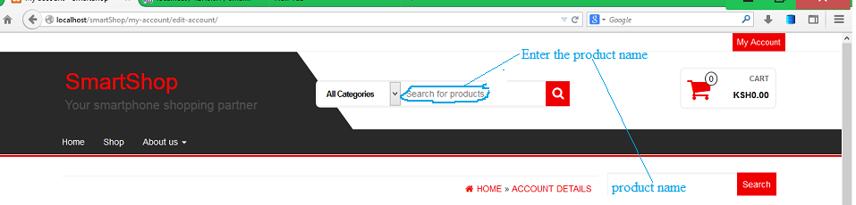
- The results of your search will be displayed.
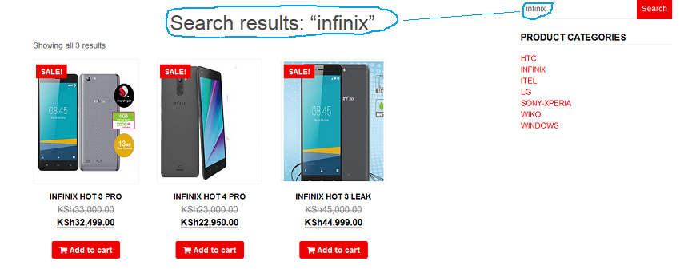
- Select the product you want.
- Click on the image to display more information about the product. However, you can just click on the “add to cart” button and proceed to payment.
Payment procedure
- Place the cursor on “cart” icon on the top right corner of the webpage. A popup with two buttons is displayed.
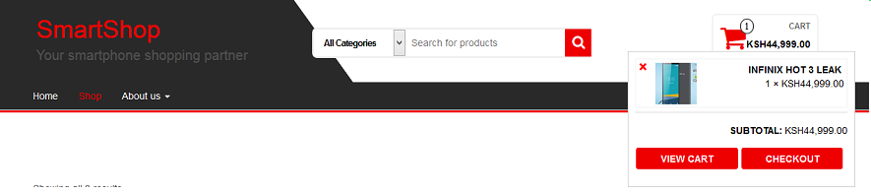
- Click on “view cart” to check the items that you have added to your cart. You can modify this information before proceeding to payments.
- Click on “checkout” button and a window will be displayed where you have to fill in your information which is required to process the payment.
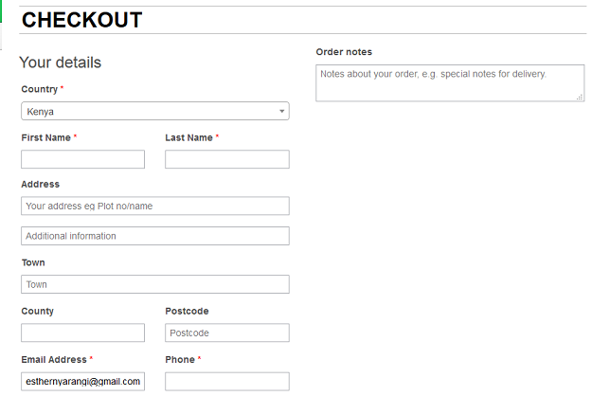
- Once you fill in your information, you can check the “create an account” checkbox to create a new user account. This is optional.
- Click on “Place order” button to complete the payment. This will redirect you to JamboPay website where you can now enter your payment details.

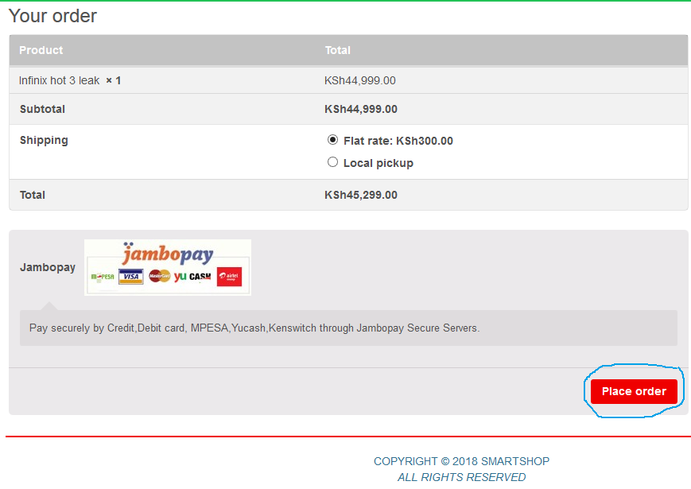

User Accounts
- Click on the Login/Register button at the top of the top of the window.
- On the window that appears, enter your details on the Register form and click on “register” button to create an account.
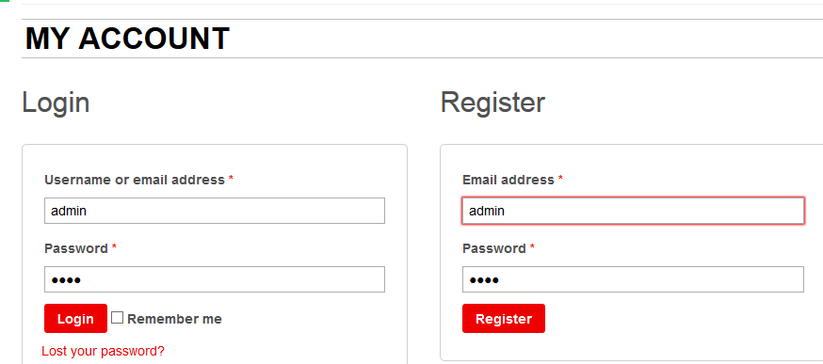
- If you have an existing account, you can enter your login credentials.
- You can edit your account details once logged in.

Appendix E Sample code
<?php
/* Retrieve list of category objects.
* @return array List of categories.
*/
function get_categories( $args = '' ) {
$defaults = array( 'taxonomy' => 'category' );
$args = wp_parse_args( $args, $defaults );
$taxonomy = $args['taxonomy'];
/* Filters the taxonomy used to retrieve terms when calling get_categories().
*/
$taxonomy = apply_filters( 'get_categories_taxonomy', $taxonomy, $args );
// Back compat
if ( isset($args['type']) && 'link' == $args['type'] ) {
_deprecated_argument( __FUNCTION__, '3.0.0',
/* translators: 1: "type => link", 2: "taxonomy => link_category" */
sprintf( __( '%1$s is deprecated. Use %2$s instead.' ),
'<code>type => link</code>',
'<code>taxonomy => link_category</code>'
)
);
$taxonomy = $args['taxonomy'] = 'link_category';
}
$categories = get_terms( $taxonomy, $args );
if ( is_wp_error( $categories ) ) {
$categories = array();
} else {
$categories = (array) $categories;
foreach ( array_keys( $categories ) as $k ) {
_make_cat_compat( $categories[ $k ] );
}
}
return $categories;
}
?>

Appendix F Sample Input
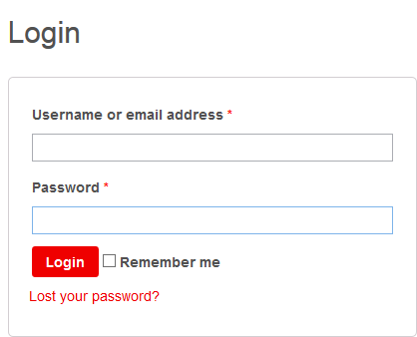

Appendix F Sample Output
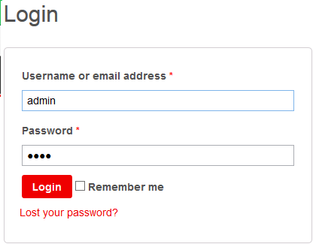

VII.Sample Test Data
admin
1234

